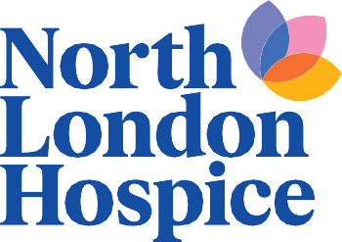

Community and Events Support Agreement

Thank you so much for choosing to support North London Hospice through your fundraising event. We rely on the generosity of people like you to help us be there for people when they need us most, so your efforts are truly appreciated.

Our Community and Events Team is on hand to assist where we can. This agreement is designed to simplify the planning process by clearly outlining the help we can provide and any limitations on our involvement.

Our Commitment

We are committed to helping make your fundraising event a success. While our support may vary depending on available resources and capacity, we will do our best to provide guidance, materials and promotional opportunities to help you achieve your fundraising goals. This includes:

Advice and guidance for your fundraiser

Fundraising materials, such as:

Leaflets

Bunting

Pull-up banners

Branded t-shirts

Collection tins and buckets

Balloons

Card readers

Please note: Fundraising materials must be collected from North London Hospice reception in Finchley unless otherwise agreed.

Providing our official "In Aid of North London Hospice" logo for use on your promotional materials.

Adding your event to our Community Events webpage.

Sharing your event on our social media channels, subject to availability within our communications schedule.

Promoting volunteer opportunities associated with your event. We have a wonderful group of volunteers who may be interested in representing the hospice at community events. While we are happy to advertise opportunities to them, we cannot guarantee volunteer availability for every event.

Our Limitations

While we're happy to offer guidance and advice where we can, there are some aspects of event delivery that we are unable to support directly due to the size of our team and the volume of events we manage. This includes:

Designing, producing, or printing event materials on your behalf.

Selling tickets or managing event registrations.

Setting up or packing down your event.

Sourcing raffle prizes, auction items or other donated goods and services.

Working Together Respectfully

Our staff and volunteers are committed to supporting fundraising activities and helping to create a positive experience for everyone involved. We ask that all interactions with North London Hospice staff and volunteers are conducted with courtesy and respect. We have a zero-tolerance approach to abusive, threatening, discriminatory, intimidating, or otherwise inappropriate behaviour. In such circumstances, we reserve the right to withdraw our involvement and support for the event.

Our Promise

We are a small but dedicated team and while we may not be able to accommodate every request, we will always do our best to support your fundraising efforts wherever we can.

Your support helps us continue providing vital care and support to local patients and their families and we are genuinely grateful for the time, energy and enthusiasm you give to North London Hospice.

Thank you for choosing to fundraise for North London Hospice. Together, we can make a real difference to those who need us most.

